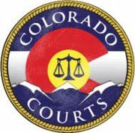
9th Judicial District’s
FAMILY LAW DAY
April 29th, 2020
9:00am – 4:00pm

Garfield County Combined Courts
109 8th St. Glenwood Springs CO 81601

** NO CHILDREN ALLOWED AT EVENT **

9:00am-4:00pm: FREE Mediation Services
- Pre-registration required
- Complete your Court ordered mediation requirement

9:00am-4:00pm: FREE Legal Advice from Local, Private Attorneys
- Pre-registration required
- 45-minute sessions

9:00am–11:00am & 1:00pm–3:00pm: Two FREE Parenting through Divorce Classes
- Pre-registration preferred
- Complete your Court ordered parenting class requirement

Participants must pre-register for Mediation and Legal Advice by Friday April 24th, 2020.

To register, please contact Rachael Leable:
Email - 09selfhelp@judicial.state.co.us
or
Phone - 970-928-3061

